1. Importance of Ipv6

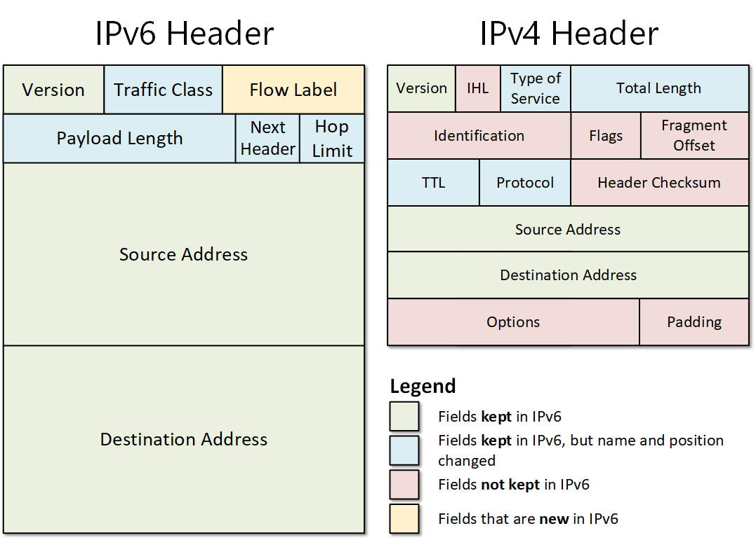

- IPv4 addresses are limited and nearly exhausted.
- IPv6 uses 128-bit addresses, giving an almost unlimited number of IPs.
- Supports the rapid growth of internet-connected devices.
- Enables better communication for IoT (smart devices).
- Improves routing efficiency with a simplified header format.
- Provides built-in security through IPsec.
- Supports auto-configuration (no need for manual IP setup).
- Reduces network congestion and improves performance.
- Eliminates the need for NAT in many cases.
- Allows direct device-to-device communication.
- Improves multicast and anycast communication.
- Ensures long-term scalability of the internet.
2. Purpose of a subnet mask
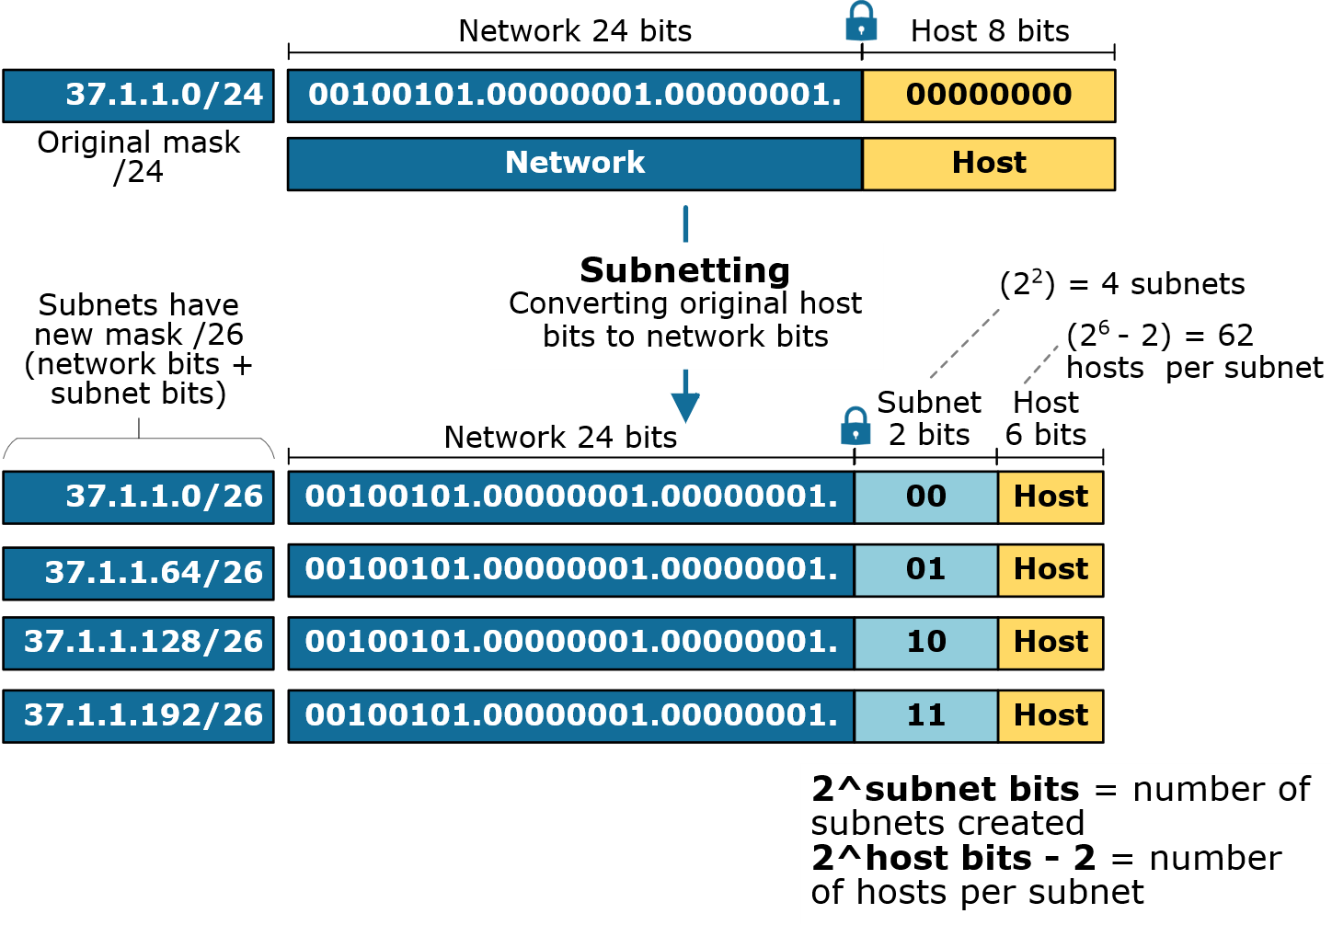
- Divides an IP address into network and host portions.
- Helps identify whether devices are in the same network.
- Organizes large networks into smaller, manageable subnets.
- Reduces unnecessary broadcast traffic.
- Improves network performance and efficiency.
- Helps in proper IP address allocation.
- Enables creation of multiple subnetworks.
- Enhances network security by isolating segments.
- Simplifies troubleshooting of network issues.
- Helps routers determine packet routing paths.
- Prevents IP address conflicts.
- Supports efficient network design and planning.
3. How NAT Helps in Home Networks
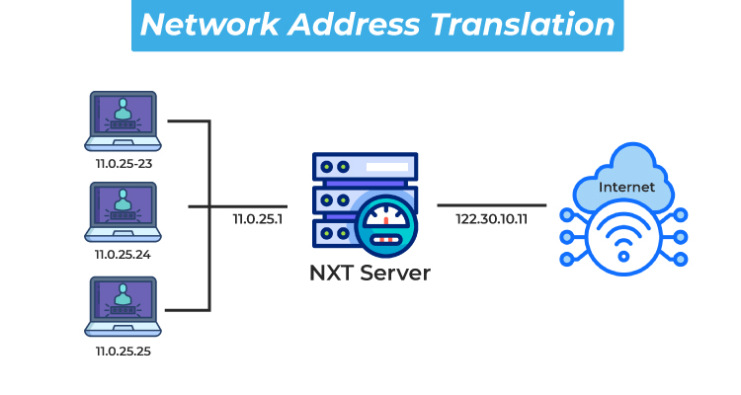
- Allows multiple devices to share a single public IP address.
- Conserves limited IPv4 addresses.
- Assigns private IP addresses within the home network.
- Translates private IPs to public IP for internet access.
- Provides an additional layer of security.
- Hides internal network details from external users.
- Prevents direct access from the internet to internal devices.
- Enables internet sharing across devices.
- Reduces the need for multiple public IPs from ISP.
- Simplifies network setup in homes.
- Supports port forwarding for specific applications.
- Helps manage traffic between internal and external networks.

